Team 2 Documentation

# Introduction

### What does the program do?

The program establishes a connection between a server and a client on port 8081.

Once the connection is established, the client can request the following commands from the server:

* UPPERCASE - The server returns the uppercase version of any string sent by the client after this command is sent to the server.
* LOWERCASE - The server returns the lowercase version of any string sent by the client after this command is sent to the server.
* REVERSE - The server returns the reverse of any string sent by the client after this command is sent to the server.
* EXIT - Will close the connection between the server and the client and end the client’s program.

### How the client and the server interact with each other:

They communicate through the application layer protocol. The client connects to the server through sockets and the sockets receive and send the messages.

# Implementation

We used Java and Eclipse to develop this project.

# Running the Program

First, run the Server program. Then in a separate terminal, run the Client program. All commands are typed in the Client program.

# Screenshots

### UPPERCASE

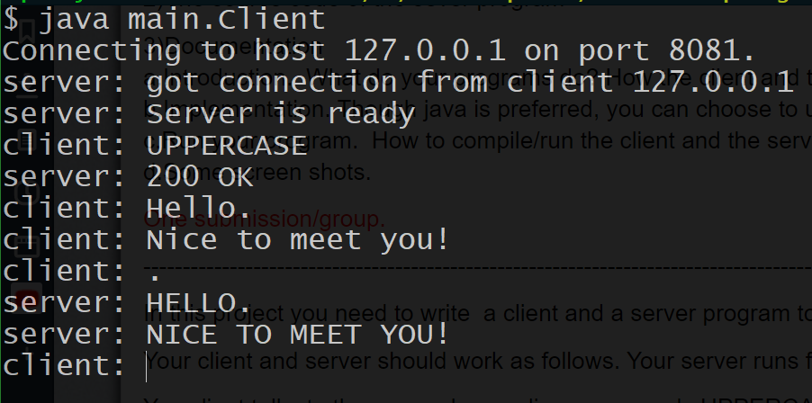

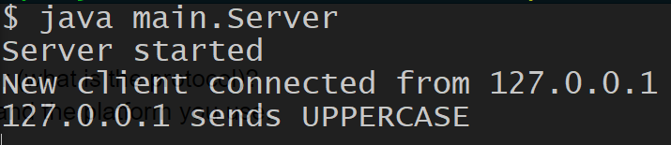

### LOWERCASE

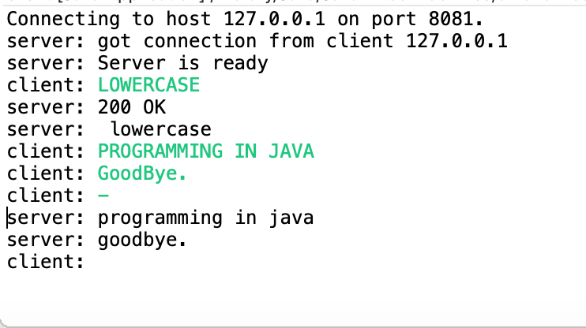

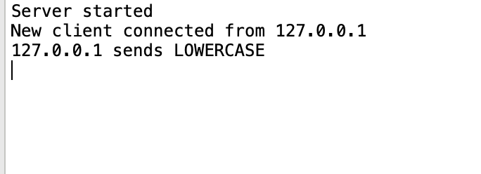

### REVERSE

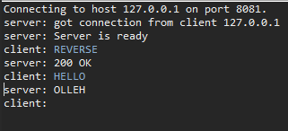

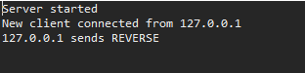

### EXIT

